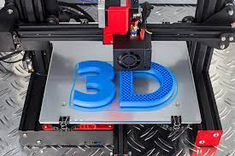

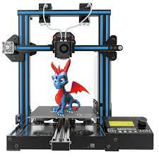

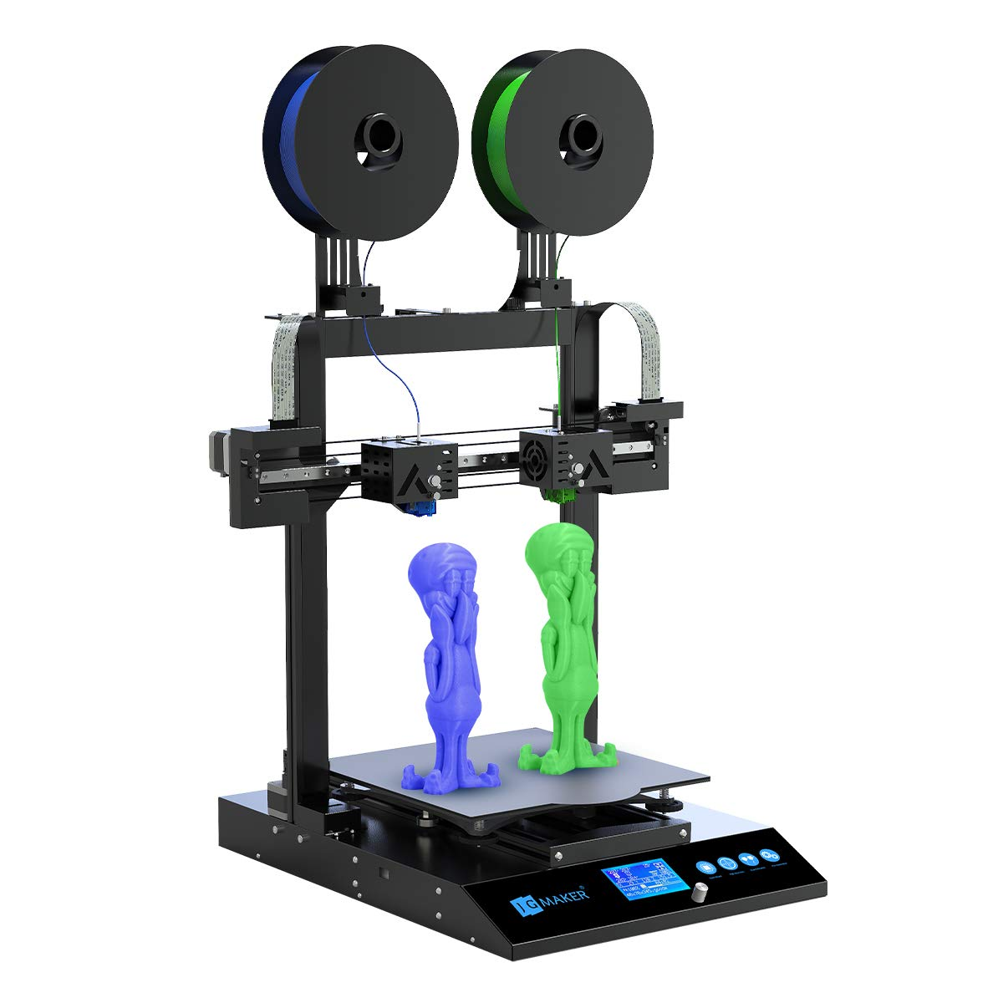

* What is 3-d printer?
* A 3-d printer is machine with the help of which we build real physical object from 3-D digital design by putting thin layers of material.

Major Components required for 3-D printers are as follow:

1) Microcontroller

2) Display

3) Stepper motor

4) Power supply

5) Stepper motor drivers

6) Heating bed

7) Extruders

8) Aluminum extrusion

9) Linear rails

10) Coupling, Timing belt and pulley

11) Limit switches

12) Lead, Screw, Nut and connecting wires as per design requirements

* Working principle:

In 3-d printer we control movement of extruder head in X, Y, Z direction with help of stepper motors. Extruder melts material with which we are working and deposits it on heating bed layer by layer. Movement of printing head depends on our 3-D design and movement of printing head is controlled by microcontroller board through stepper motors. Steps of stepper motor and micro-stepping of stepper motor driver affects precision of final print. And size of nozzle of printing head and microcontroller board used affects speed of printing to some extent.

* Real Life application:
* 3-D printer makes production of complex design which is hard to produce using traditional method easy.
* We can get our physical product ready with minimum loss of material.
* Production of unique of specific parts of small scale in less time and more precision is possible using 3-D printer.